**Photonics and Laser Technology**

**Comprehensive Program Review Data Packet**

**7A. Enrollment Trends**

**Use the data provided by PRIE to examine your enrollments by department or courses. Describe trends in headcount, FTES, and load. If applicable, describe any other enrollment data that is relevant to your program**

Enrollment for PALT declined from 18 to 3 between 2022-2023 and 2023-2024. Headcount decreased from 6 to 3 between the same time frames.

Section count declined from 6 to 1 between 2022-2023 and 2023-2024.

FTEF went from 2 to 0 between 2022-2023 and 2023-2024. FTES went from 3 to 1 between 2023-2024.

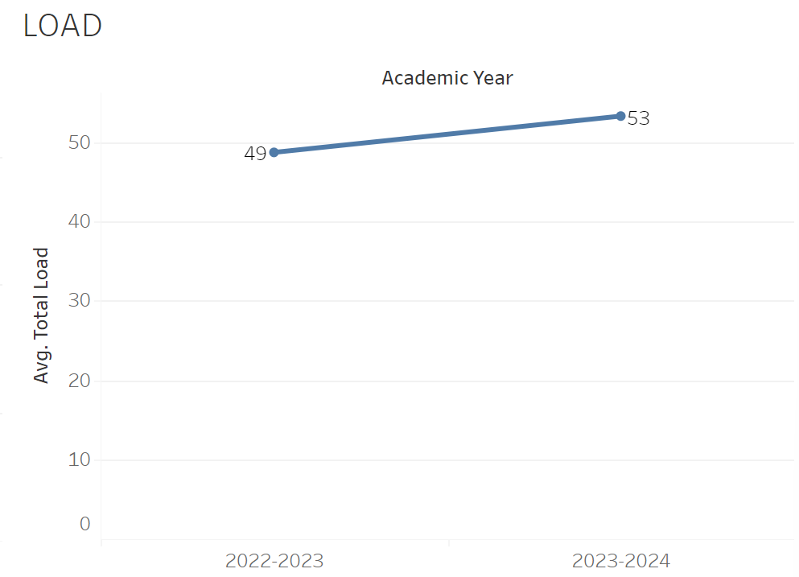

Load increased from 49 to 53 between 2022-2023 and 2023-2024.

**8A. Access & Completion**

**Describe the student completion and success rate in your courses and/or program using the data provided by PRIE. Look at your course offerings, in the last program review cycle was it possible for a student to complete your certificates or degrees while only completing courses at Cañada College? How can the college help you improve student completion and success? What changes could be made?**

Note: See the *Course Enrollment & Success Detail Report* for additional course-level data. This report can be found onPRIE’s [Data Dashboards & Packets](https://canadacollege.edu/prie/data-dashboards.php) page under the program name.

The success rate went up from 97% to 100% between 2022-2023 and 2023-2024. The Withdraw rate stayed at 0 consistently.

PALT-403 had the lowest success rate of 80% while PALT 402 had the highest of 100%. Both had a withdraw rate of 0%.

**8C. Completion – Success Online**

**The college has a goal of improving success in online courses. Using the data provided by PRIE, what significant gaps do you see in success between online/hybrid and non-online courses? What changes could be made to reduce these gaps?  If your program does not offer online/hybrid courses, please write “not applicable”.**

The success rate for face to face classes was 100% in 2022-2023.